Tutorial-5

Modules name:Amazon
Test Case ID:Bug_004
Environment Information:os:macos(Sequoria 15.5)system : laptop(macbook air)webpage URL:https://share.google/NsrVNMtMH27TvDShu

Screenshort:
Scenario 1:

Demo login page:Open the Amazon
Test Steps:1a
1.Serach Amazon application
2.open the mobile screen

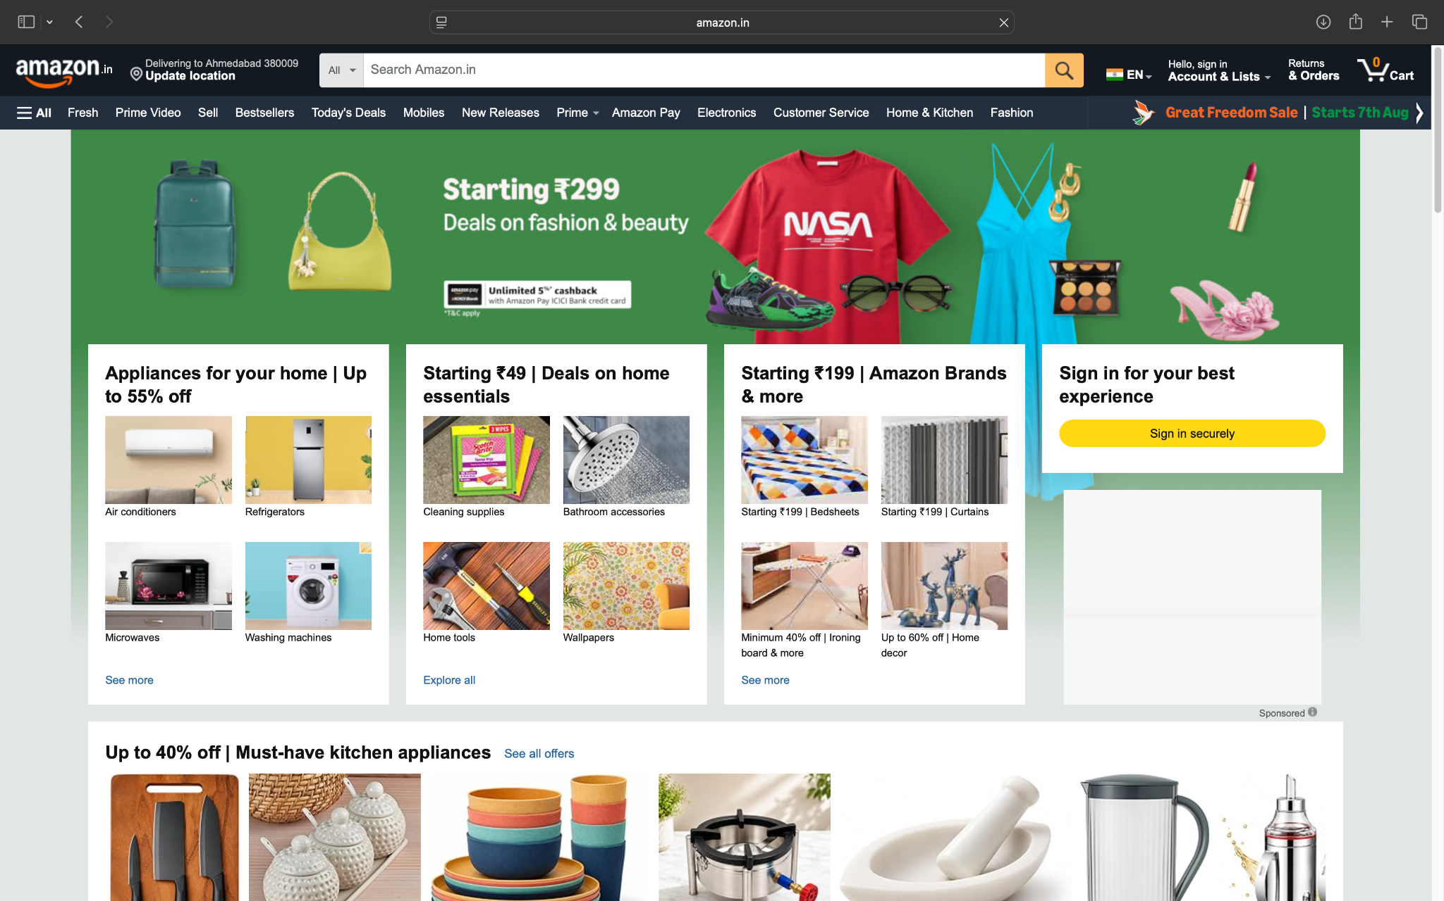

Screenshort:
Scenario 1:

Demo login page:Open the Amazon valid login page
Test Steps:1b
1.Serach Amazon application
2.open the mobile screen
3.login the amazon account

Screenshort:
Scenario 1:

Demo login page:Open the Amazon invalid login page
Test Steps:1c
1.Serach Amazon application
2.open the mobile screen
3.inlogin the amazon account

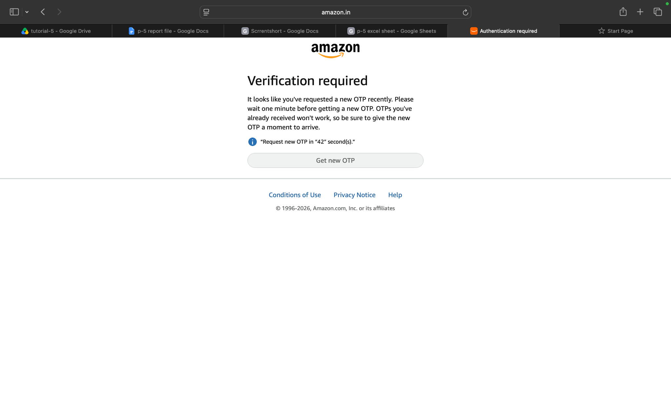

Screenshort:
Scenario 1:

Demo login page:Open the Amazon product display
Test Steps:1d
1.Serach Amazon application
2.open the mobile screen
3.login the amazon account
4.amazon product check in

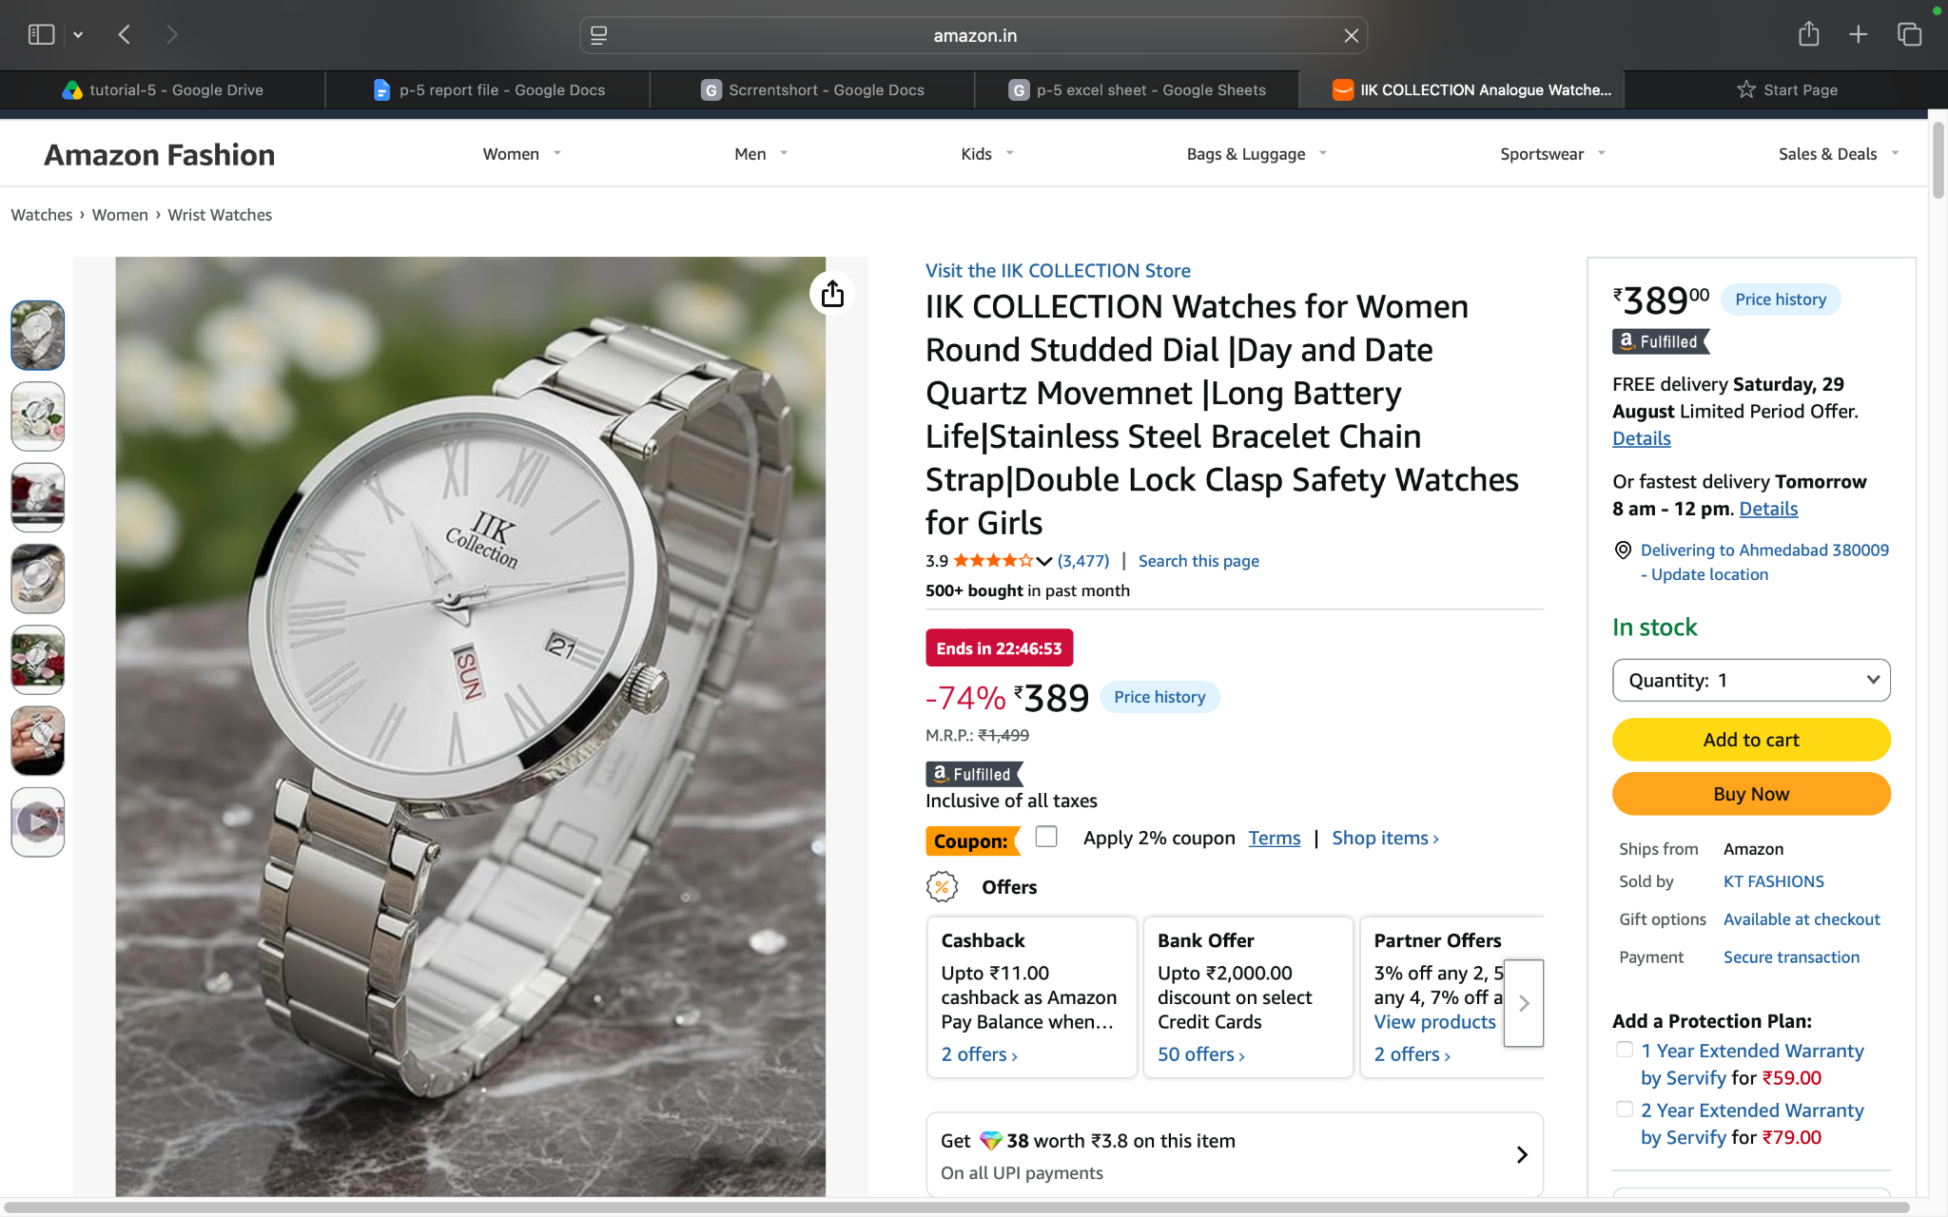

Screenshort:
Scenario 1:

Demo login page:Open the Amazon product add to cart
Test Steps:1e
1.Serach Amazon application
2.open the mobile screen
3.login the amazon account
4.product check in and add to cart

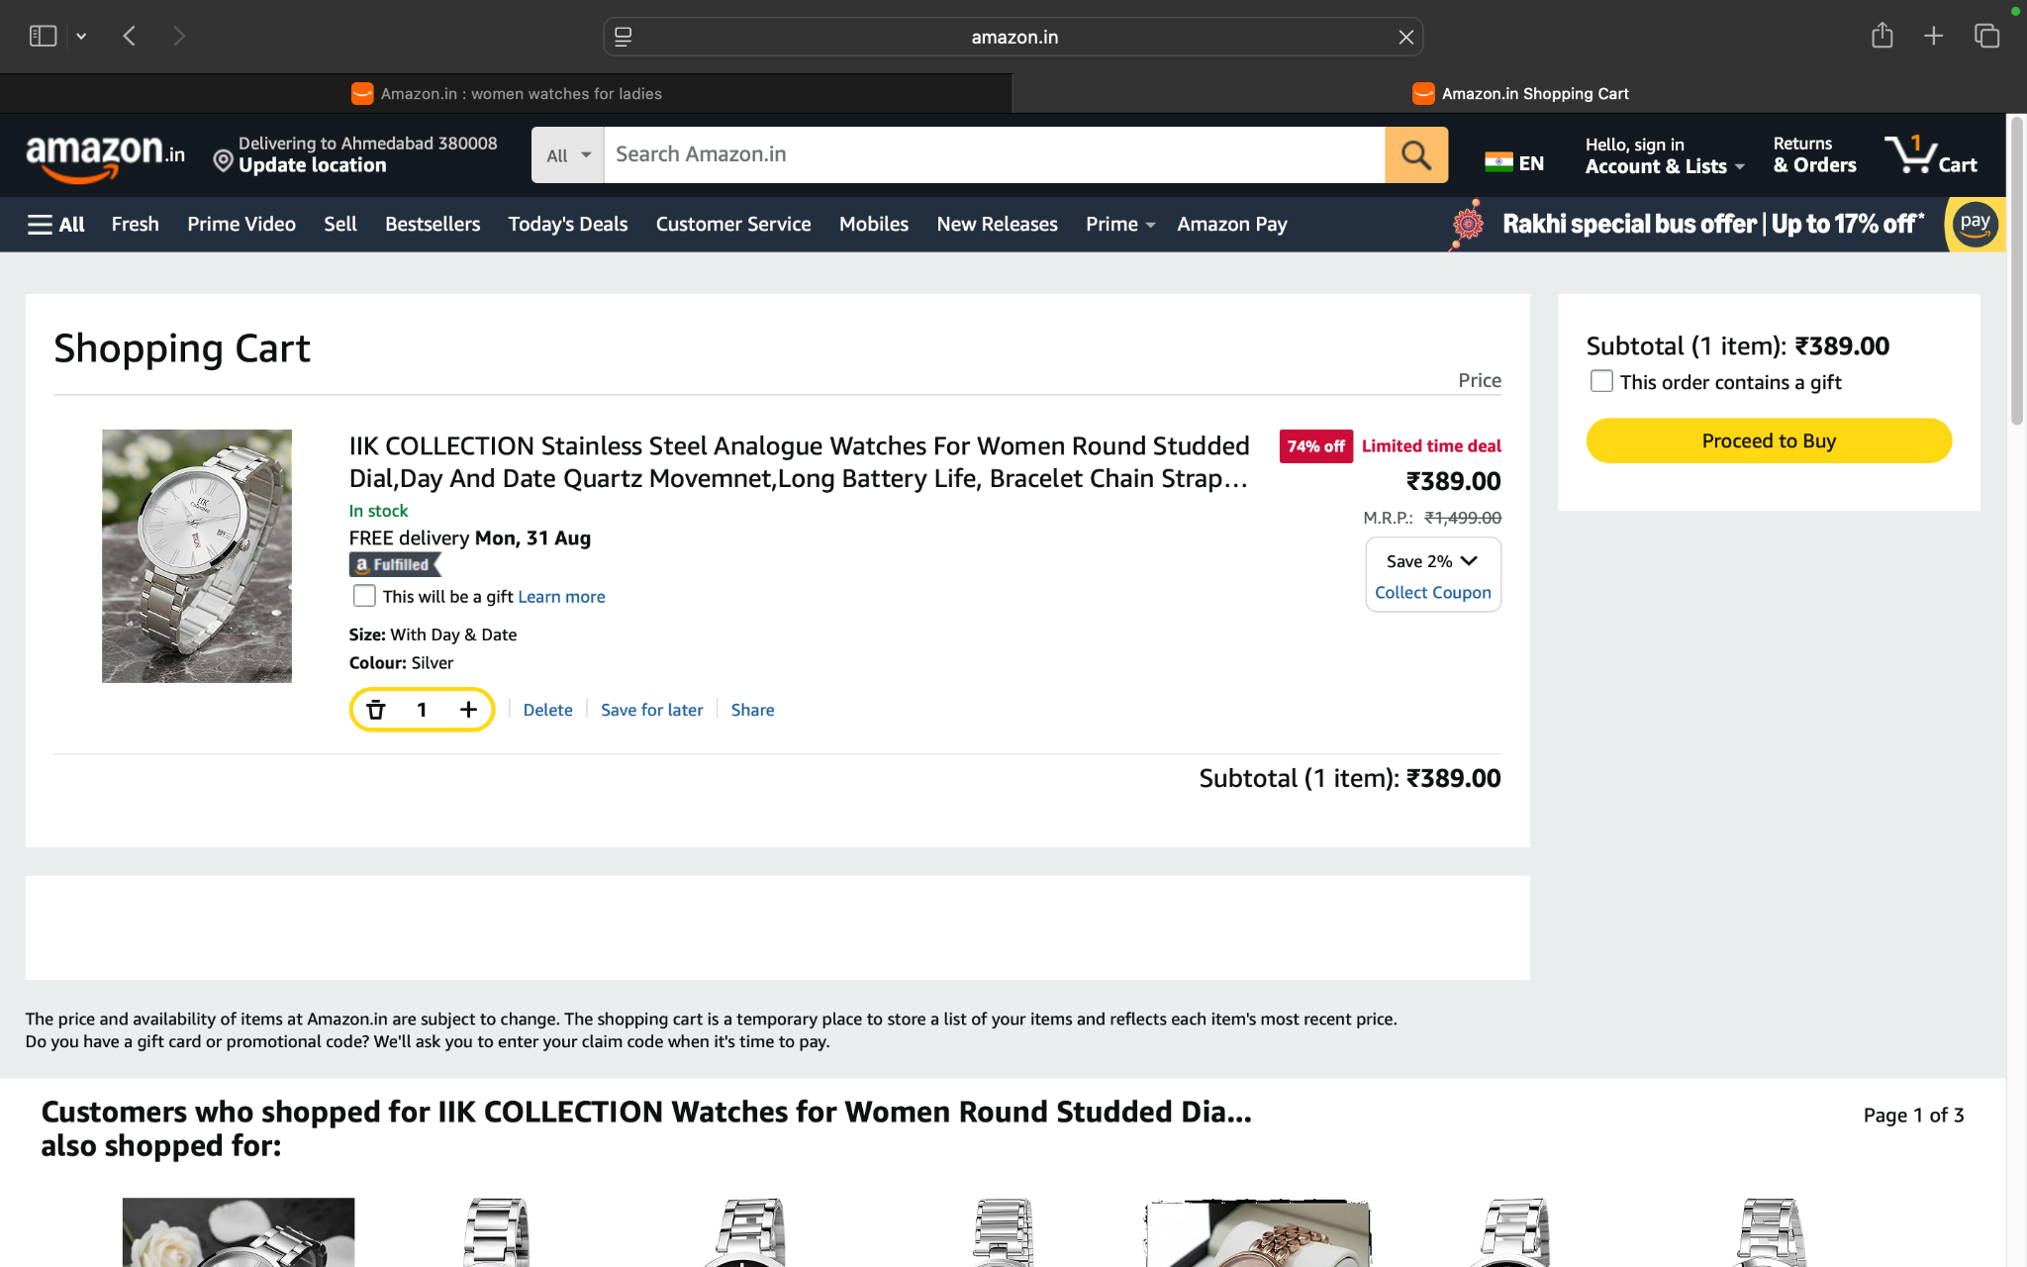

Screenshort:
Scenario 1:

Demo login page:Open the Amazon product remove the add to cart
Test Steps:1f
1.Serach Amazon application
2.open the mobile screen
3.login the amazon account
4.product check in and add to cart
5.product remove the cart
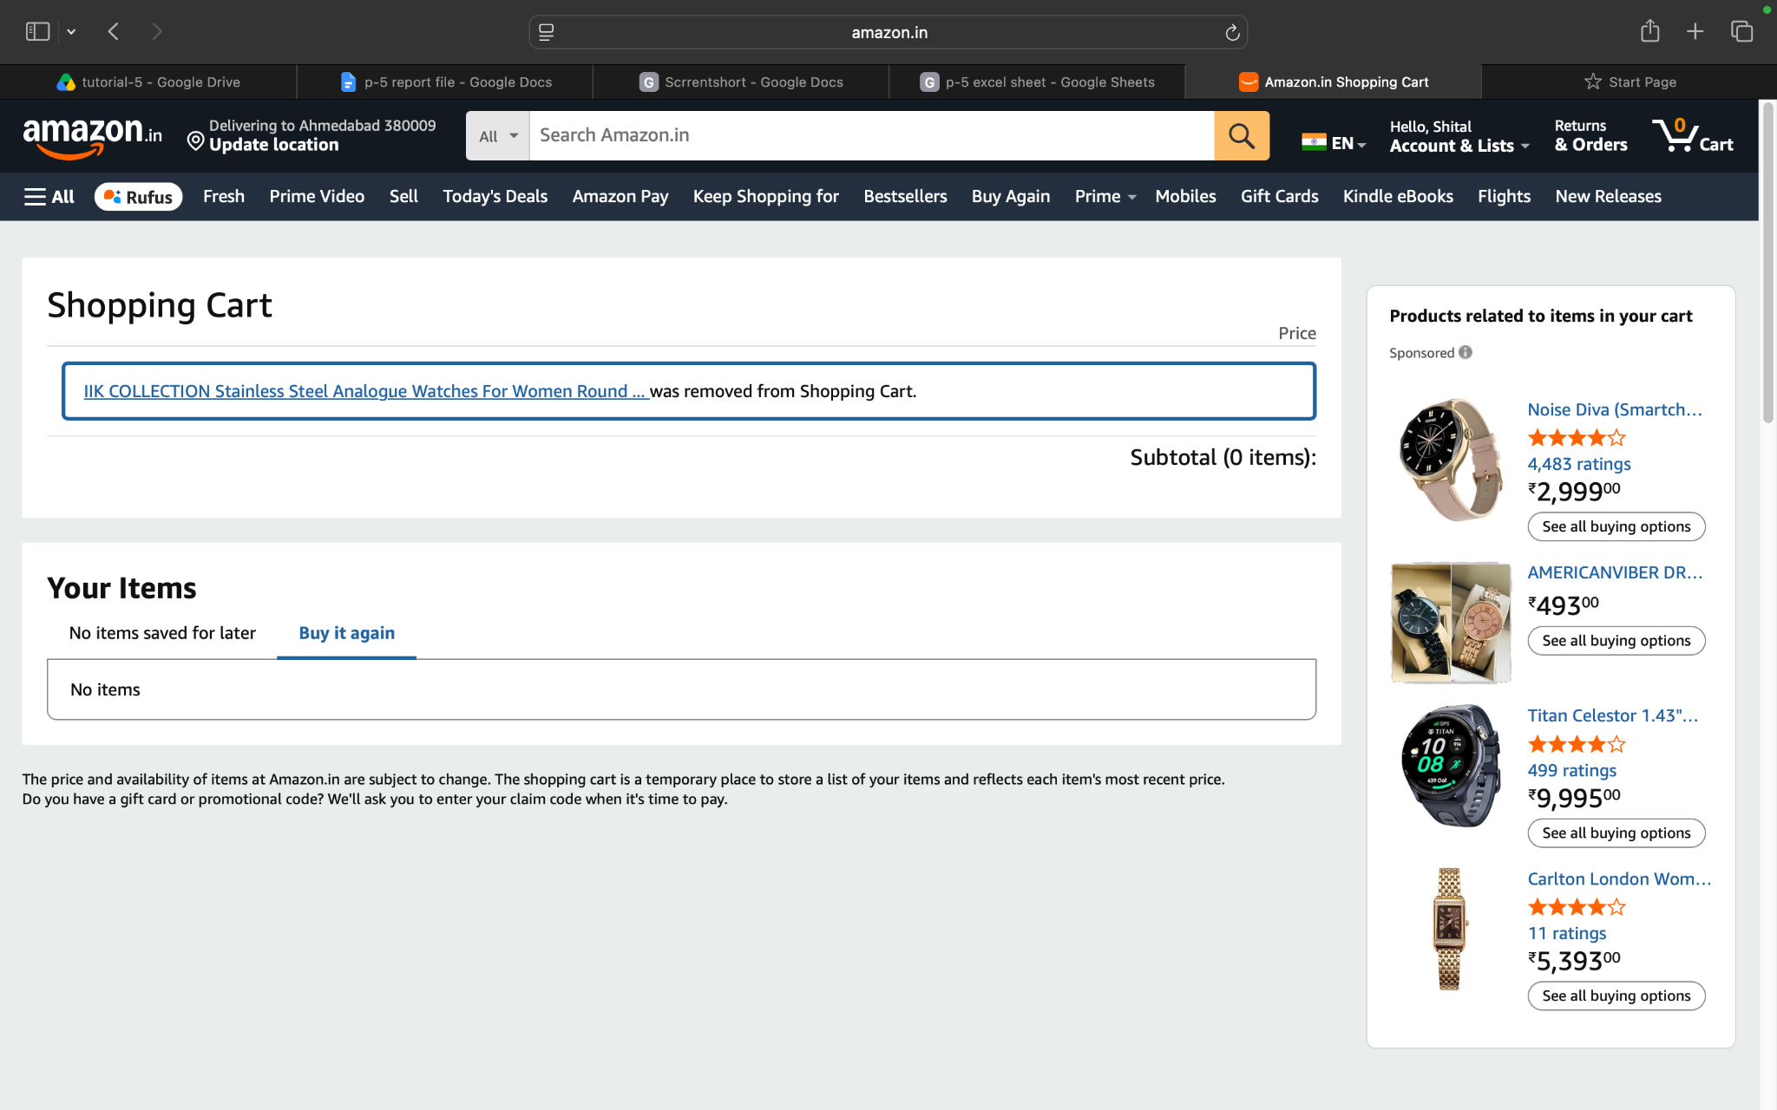

Screenshort:
Scenario 1:

Demo login page:Open the Amazon product qualitity
Test Steps:1g
1.Serach Amazon application
2.open the mobile screen
3.login the amazon account
4.product check in and add to cart
5.product quantity check in
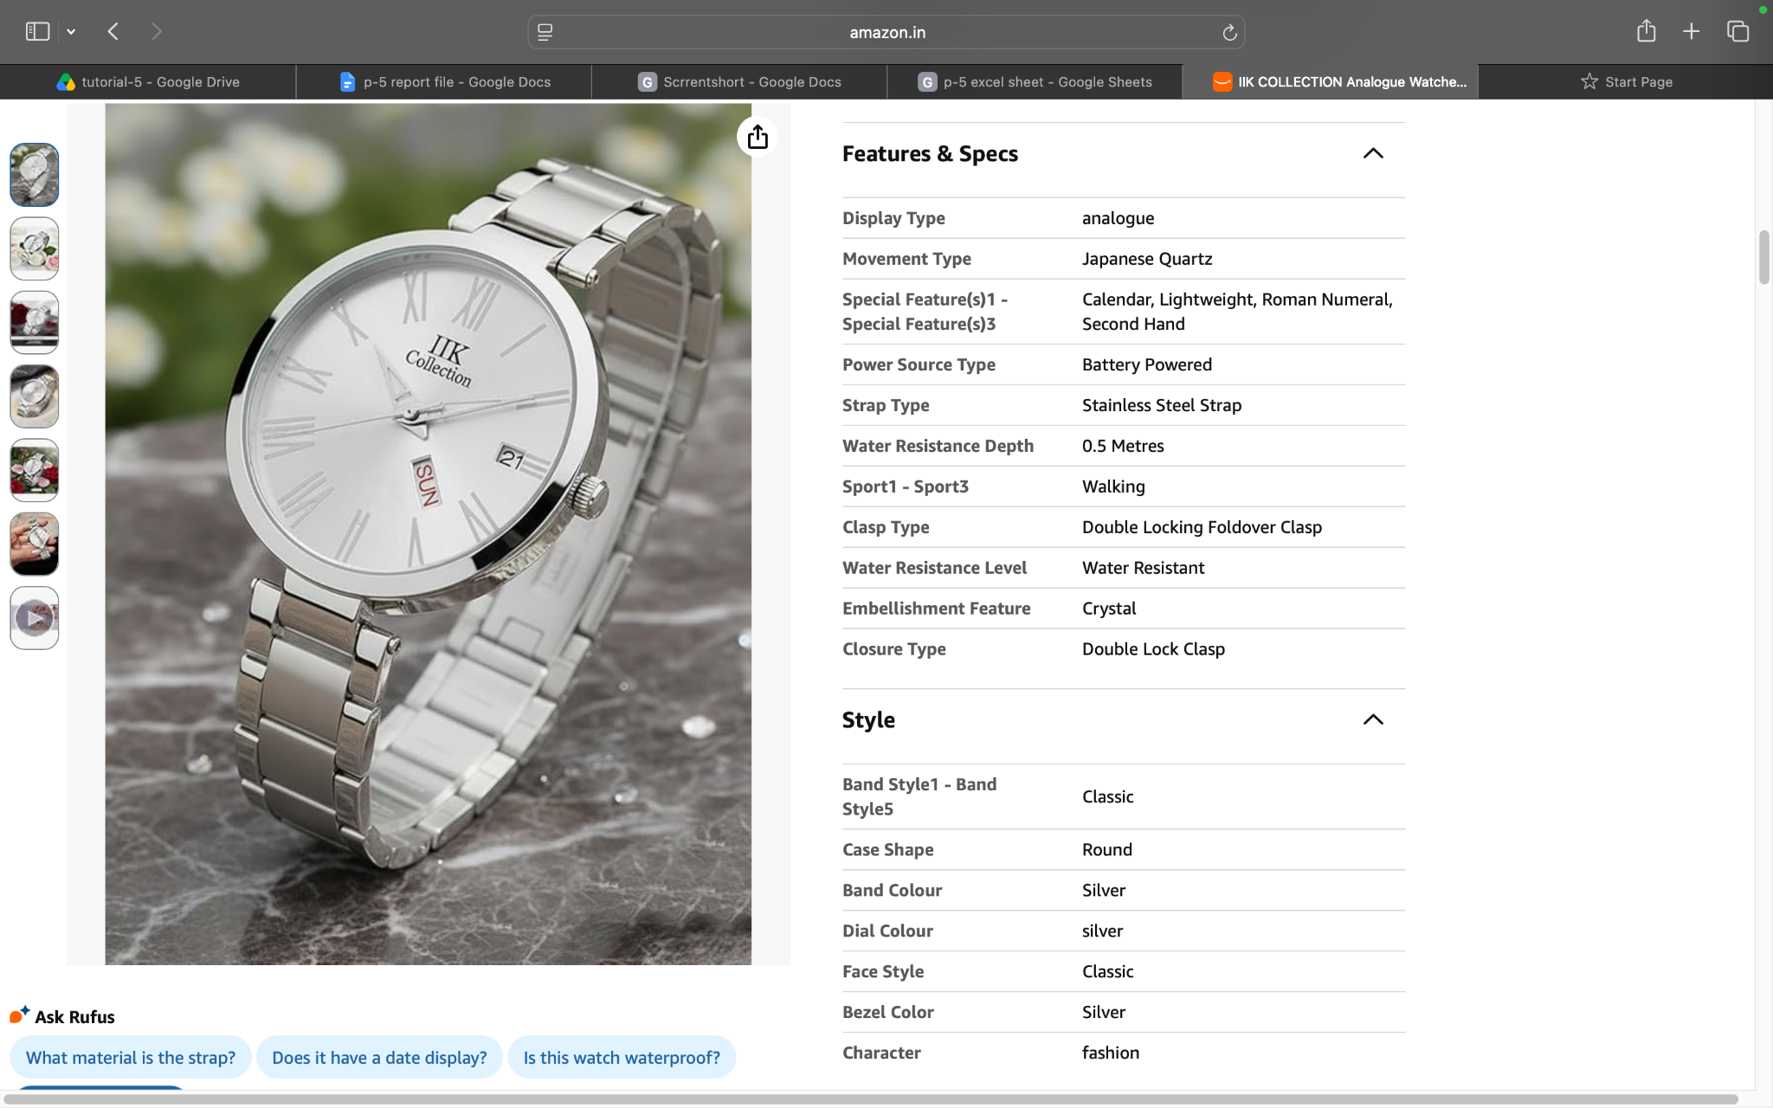

Screenshort:
Scenario 1:

Demo login page:Open the Amazon product check out in
Test Steps:1d
1.Serach Amazon application
2.open the mobile screen
3.login the amazon account
4.product check in and add to cart
5.product check out in

Screenshort:
Scenario 2:

Demo login page:logout the Amazon account
Test Steps:2a
1.Serach Amazon application
2.open the mobile screen
3.login the amazon account
4.product check in and add to cart
5.amazon account logout in

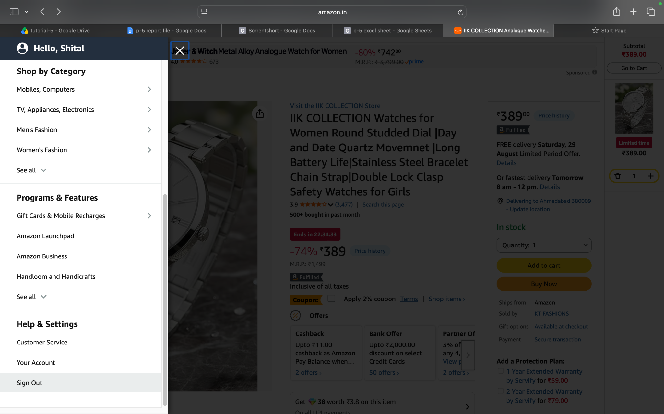

Screenshort:
Scenario 2:

Demo login page:amazon account login into
Test Steps:1d
1.Serach Amazon application
2.open the mobile screen
3.login the amazon account
4.product check in and add to cart
5.amazon account logout in
6.back to login in
